### Details of the functionality and features

### 

Figure 1 : Student login page to access study notes

(+) added register and forgot your password, will create pages in 3rd revision  
(+) added video at the bottom to show a tutorial on how to use the system

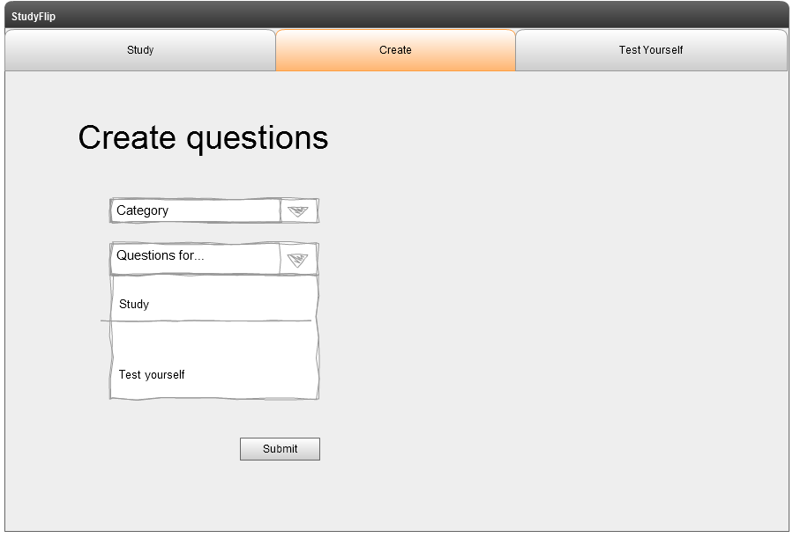

Figure 2: Student create questions page. Study or Test Yourself

(+) added category option for users to select what category the topic is associated with the subject

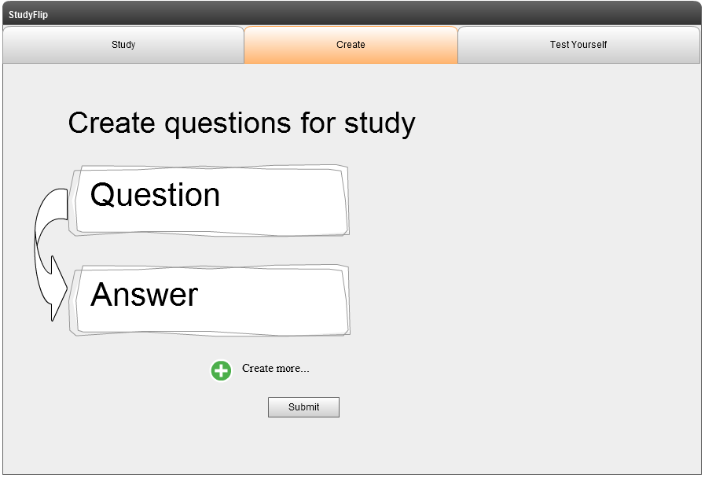

Figure 3: Student creates questions for study

(+) changed button create more

### 

Figure 4: After creating study questions, student clicks on study tab and presented topic selection

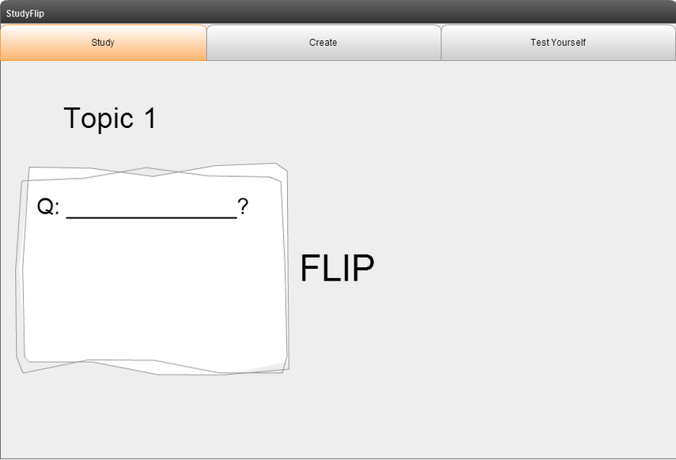

Figure 5: Student is presented the first question, then on a sheet of paper the student writes an answer

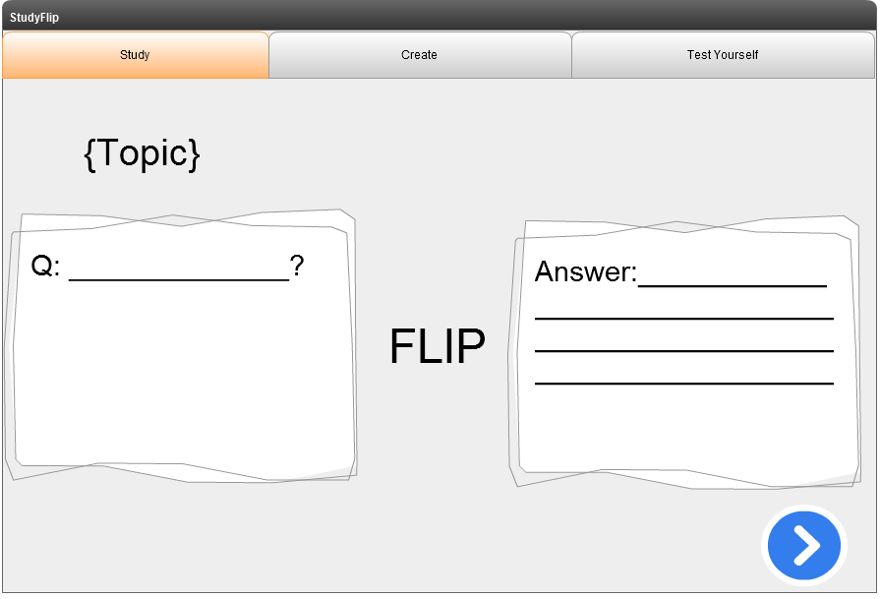

Figure 6: Student clicks flip and is shown the answer. Student then looks at the answer and clicks next when finished

(+) Question stays up for student to compare model answer to written answer  
(+) Added blue arrow for next question

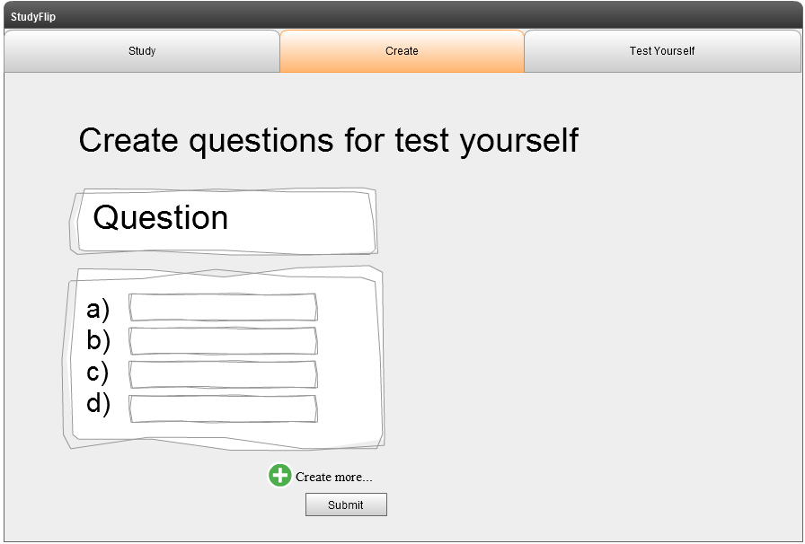

Figure 7: Student clicks create questions and enters questions and multiple choice answers

(+) Added boxes for border of text  
(+) Changed create more button

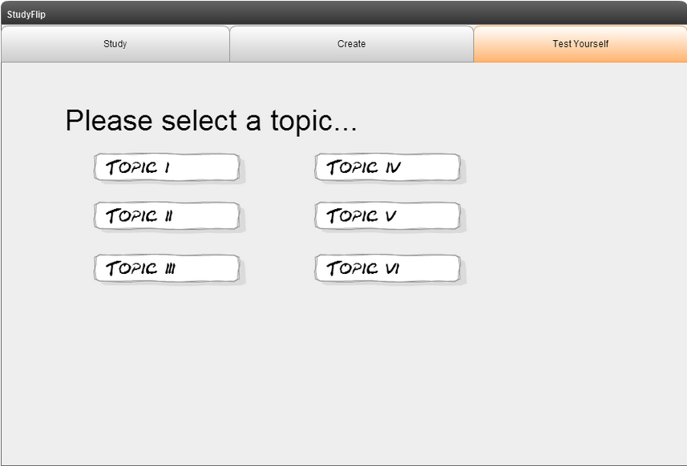

Figure 8: After creating a test yourself topic, user clicks on test yourself and is presented the topic selection page

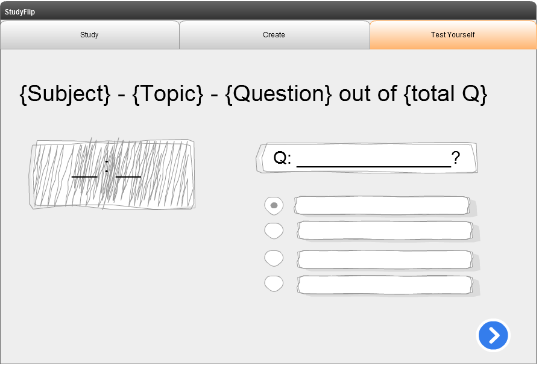

Figure 9: Once test starts, timer can be shown with questions and multiple choice answers.

(+) Radio buttons implemented instead of drop down  
(+) Added blue arrow for next question  
(-) Removed percentage score and statistics for simplicity  
(note) instead of user checking if answer is correct after every single question, there will be a results page upon completion of the test (see figure 10)

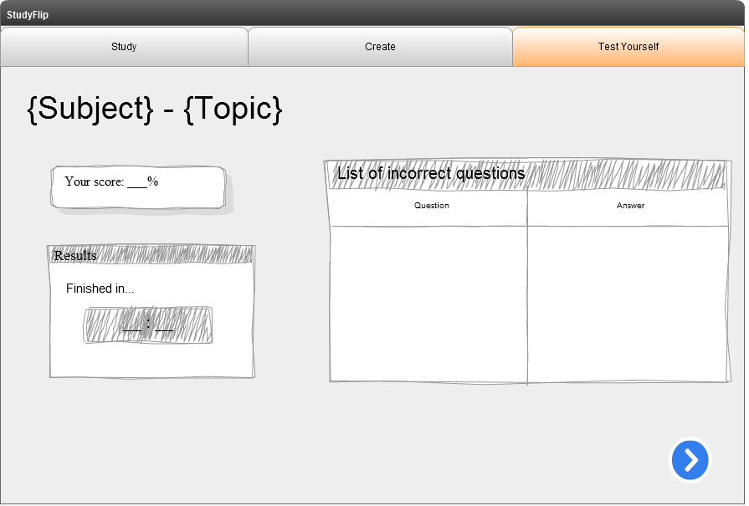

Figure 10: Once test starts, timer can be shown with questions and multiple choice answers.

(+) Added total score, finishing time and list of incorrect questions